WHO HEALTHCARE ANALYTICS: LEVERAGING MACHINE LEARNING TO UNRAVEL GLOBAL LIFE EXPECTANCY FACTORS

Introduction:
Life expectancy is a critical measure of a nation's overall health and well-being. Understanding the factors influencing life expectancy across different countries is essential for tailoring effective interventions. This research endeavors to provide valuable insights for international business and healthcare professionals to formulate effective strategies. By employing regression analysis and exploratory data analysis (EDA) to examine the relationship between key health indicators, income, region, and life expectancy across nations, this project aims to uncover actionable insights. These insights will empower professionals to tailor strategies that address specific health challenges and socioeconomic factors, ultimately contributing to improved global health outcomes and facilitating informed decision-making in both the business and healthcare sectors. A similar analysis is done by the WHO analytics but what sets this research apart from WHO is that usually, we see most of the businesses following the marketing analytics based on the current market trends or consumer analytics, and they often ignore things like the analytics or the user behavior and patterns that come from other industries, so this data analysis that we are providing giving the data of different countries across the world will help a lot of global businesses to understand the current lifestyle, health and behavioral patterns of consumers across the world. Since we are living in a world of personalization today, I think this kind of analytics will help companies personalize or customize their products. There are advertising campaigns and their approach to deal with customer satisfaction based on the data. Instead of just bothering about the cultural aspect of each nation, I think understanding the healthcare behaviors and lifestyle of their consumer groups. Different countries will help them to identify new opportunities and make better utilization of the existing ones.

Data:
Datasets used:
WHO World Health Statistics Report 2023
World Bank Classification
WHO World Health Statistics Report
The World Health Organization (WHO) publishes the World Health Statistics Report every year, which provides a detailed summary of global health trends and statistics. The report covers a wide range of health indicators, including mortality rates, disease burden, healthcare coverage, and health system performance metrics. Policymakers, researchers, and healthcare professionals can use this report as a valuable resource to understand and address global health challenges.

World Bank Classification
The World Bank Classification is a system that groups countries into different income categories based on their Gross National Income (GNI) per capita. The four income groups are low-income, lower-middle-income, upper-middle-income, and high-income. This classification helps to evaluate the economic development status of countries and enables comparisons between them. It is commonly used in development economics and public health research to study the correlation between economic factors
Variables being used:
Countries and areas: Names of countries or regions included in the dataset.
Region: Geographic regions or continental areas to which the countries belong(World Bank classification)
Income Group: Categorization of countries based on their income level (e.g., low income, middle income, high income)(World Bank Classification)
Life expectancy at birth: The average number of years a newborn is expected to live at birth.
Healthy life expectancy at birth: The average number of years a newborn is expected to live in good health, without disability or illness.
Probability of dying from any of CVD, cancer, diabetes, CRD between age 30 and exact age 70: The probability of dying from any of the listed non-communicable diseases between the ages of 30 and 70.
Suicide mortality rate: The number of deaths by suicide per 100,000 population in a given time period.
Total alcohol per capita consumption: The average consumption of pure alcohol per person aged 15 years and older, measured in liters.
Road traffic mortality rate: The number of deaths due to road traffic accidents per 100,000 population in a given time period.
Malaria incidence: The number of new cases of malaria per 1,000 population at risk in a given time period.
Tuberculosis incidence: The number of new cases of tuberculosis per 100,000 population in a given time period.
Age-standardized prevalence of obesity among adults (18+ years): The age-standardized prevalence of obesity among adults aged 18 years and older, expressed as a percentage.
Proportion of population using safely-managed sanitation services: The percentage of the population that has access to safely managed sanitation services.
We use the above variables in the dataset to investigate the variations in factors influencing life expectancy across different regions and income groups, determine the extent of differences in the impact of specific factors on life expectancy among various countries, and develop targeted interventions for international business and healthcare professionals based on country-specific findings to improve life expectancy outcomes.

Methodology:
The project utilizes Google Collab and Excel for data analysis, along with essential Python libraries such as Numpy Pandas, Seaborn, Matplotlib, Scikit-learn, and Statsmodels.
Data Collection and Preprocessing: Before analysis, the dataset undergoes thorough preprocessing, including handling missing values, removing duplicates, and standardizing variables, ensuring data quality and consistency.
Exploratory Data Analysis (EDA): Through EDA, the project uncovers variations and patterns in factors across countries, using Pandas, Seaborn, and Matplotlib for visualization and summarization.
Multiple Regression Analysis: The project employs Multiple Regression Analysis, facilitated by Scikit-learn and Statsmodels, to understand the relationship between life expectancy and various factors, deriving meaningful insights for decision-making.

Results:
From our analysis, we were able to get the following results:
Error distribution:
After conducting an error distribution analysis, I discovered a normal distribution of errors in the data. This finding indicates that our statistical model effectively captures the variability in the observed data and validates fundamental assumptions underlying our analysis. Moving forward, this normal error distribution enhances the reliability of our research findings, allowing for more confident statistical inference and enabling us to draw robust conclusions about the relationships between variables or the effects of interventions.
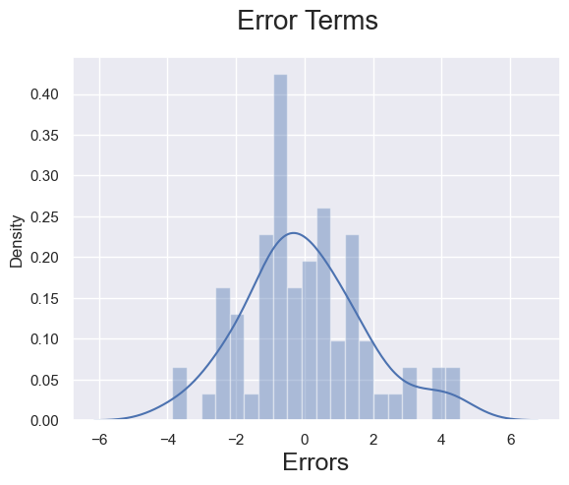

Regression Analysis:
The provided regression analysis results indicate the following:
1. Mean Squared Error (MSE): The mean squared error measures the average squared difference between the actual values of the dependent variable (life expectancy) and the predicted values from the regression model. In this case, the MSE is approximately 3.75, indicating that, on average, the squared difference between observed and predicted life expectancy values is around 3.75 units.
2. R-squared: The coefficient of determination (R-squared) measures the proportion of the variance in the dependent variable that is explained by the independent variables included in the model. With an R-squared value of approximately 0.82, this indicates that approximately 82% of the variability in life expectancy is accounted for by the independent variables in the model.
3. Regression Equation Coefficients: The coefficients represent the estimated effects of each independent variable on the dependent variable (life expectancy) while holding other variables constant. In this case, each coefficient represents the change in life expectancy associated with a one-unit change in the corresponding independent variable. For example, a one-unit increase in cancer deaths is associated with a decrease of approximately 0.403 units in life expectancy, holding other variables constant.
4. Regression Equation Intercept: The intercept represents the estimated value of the dependent variable (life expectancy) when all independent variables are zero. In this case, the intercept is approximately 85.47, indicating that, in the absence of any other factors (when all independent variables are zero), the estimated life expectancy is around 85.47 years.
Overall, these results suggest that the regression model has a good fit, as indicated by the relatively high R-squared value. The coefficients provide insights into the direction and magnitude of the effects of each independent variable on life expectancy, while the intercept represents the baseline life expectancy when other factors are absent.

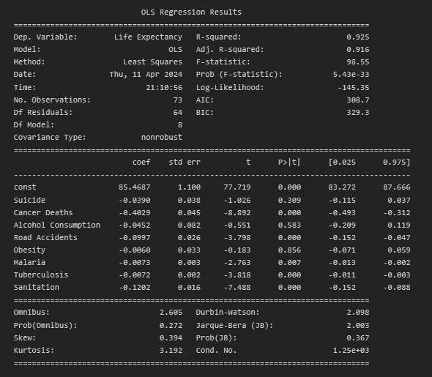

Exploratory Data Analysis through Visualizations:
1. Heatmap: From the correlation plot, we can see that none of the variables are highly correlated, which indicates that the model does not have multi-collinearity issues

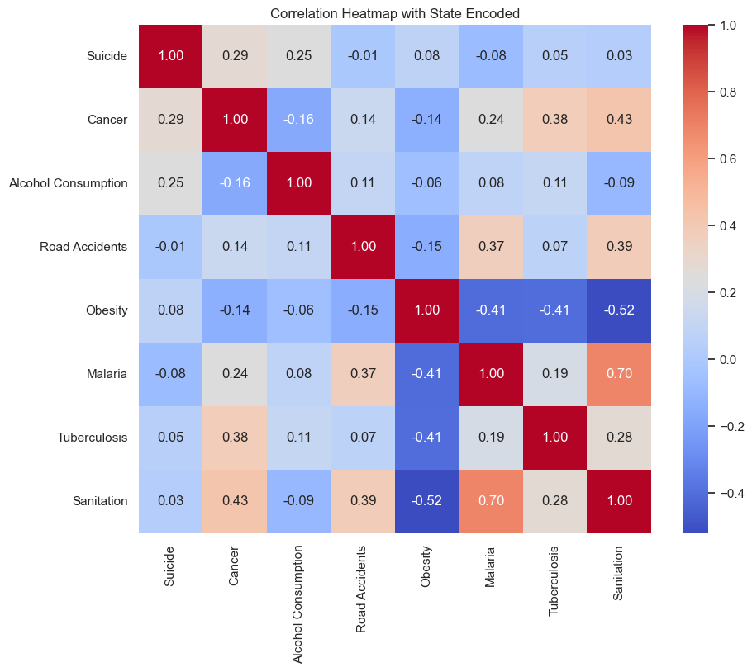
Other Visualizations: In this project, I have used various other visualizations apart from heatmap to understand the impact of different variables on life expectancy.
Different visualizations performed on the dataset are as follows: Boxplots, histograms, Line graphs, violin plots, bar graphs, and scatter plots.
Through these, we were able to analyze that when looking at the life expectancy trend from an income group standpoint, high-income economies have the highest life expectancy of 79.45 years. While low-income economies have the lowest life expectancy of 64 years. Also except for the 12 countries, the life expectancy at the birth rate is greater than the ideal (healthy life expectancy) for rest of the countries meaning which countries life expectancy indicators are not showing alarming concerns. Apart from that, we can see how variables affect different countries differently, and based on these visualizations many international business and healthcare sectors will be able to come up with custom strategies for each country to improve their sales and connect better with their customers.
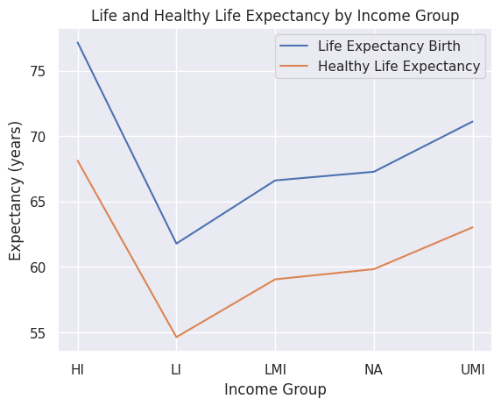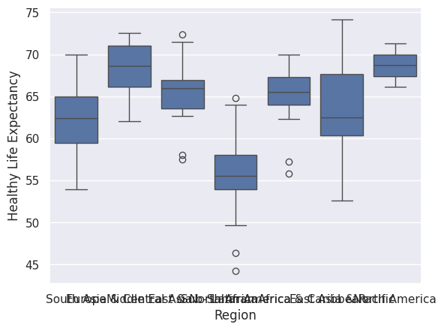

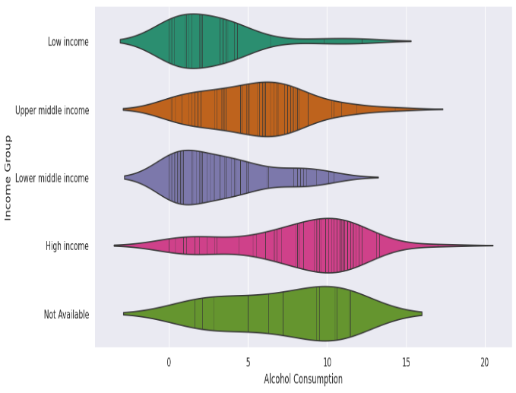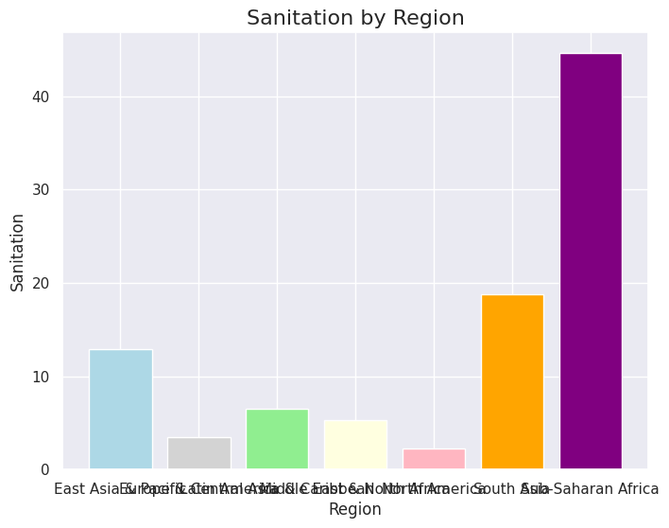

Implementations and Recommendations:
Global Businesses:
1. Personalized Marketing and Customer Segmentation: - Utilize consumer health data to tailor marketing campaigns and promotions for specific customer segments, increasing engagement and loyalty.
2. Health and Wellness Product Development: - Develop products based on consumer health trends and preferences to address specific health concerns and resonate with health-conscious consumers.
3. Supply Chain Optimization and Inventory Management: - Apply analytics to healthcare supply chain data to improve inventory forecasting, streamline logistics, and enhance operational efficiency for cost savings and improved product availability.
4. Customer Experience Enhancement: - Offer personalized health-related recommendations and services based on consumer health behaviors and preferences to meet the evolving needs of health-conscious consumers.
5. Risk Management and Product Liability: - Proactively identify risks related to product liability and consumer health concerns using health data and consumer feedback to ensure product safety, compliance, and maintain consumer trust.
6. Data Privacy and Security Compliance: - Implement data protection practices from healthcare analytics to safeguard consumer health data, ensure regulatory compliance, and build trust with customers regarding sensitive health information.
7. Market Trend Analysis and Competitive Intelligence: - Analyze health-related market trends, consumer behaviors, and competitive landscape to identify opportunities, anticipate consumer preferences, and make informed strategic decisions to stay ahead in the market.

HealthCare Professionals:
1. Predictive Analytics for Early Disease Detection: - Research in predictive analytics can focus on developing models to detect diseases at an early stage based on patient data, biomarkers, and risk factors. - By leveraging predictive analytics, healthcare providers can intervene proactively, leading to early diagnosis, timely treatment, and improved health outcomes for patients.
2. Precision Medicine and Genomic Analytics: - Further research in genomic analytics can enable the advancement of precision medicine by tailoring treatment plans based on individual genetic profiles. - By integrating genomic data with clinical information, researchers can identify personalized treatment strategies, optimize drug selection, and enhance therapeutic outcomes for patients.
3. Telehealth and Remote Monitoring: - The application of analytics in telehealth and remote monitoring can facilitate real-time data analysis for virtual patient consultations and remote health management. - By leveraging analytics tools, healthcare providers can monitor patient health remotely, deliver personalized care, and improve access to healthcare services, especially in underserved areas.
4. Healthcare Operations Optimization: - Research in healthcare operations analytics can focus on optimizing resource allocation, workflow efficiency, and patient flow within healthcare facilities. - By analyzing operational data, researchers can identify bottlenecks, streamline processes, and enhance the overall efficiency of healthcare delivery, leading to improved patient experiences and cost savings.
5. Drug Safety and Pharmacovigilance Analytics: - Further exploration in pharmacovigilance analytics can enhance drug safety monitoring, adverse event detection, and post-market surveillance of pharmaceutical products. - By analyzing real-world data and adverse event reports, researchers can identify potential safety concerns, assess drug effectiveness, and support regulatory decision-making to ensure patient safety.
6. Population Health Analytics and Epidemiological Studies: - Research in population health analytics can focus on analyzing health trends, disease patterns, and social determinants of health to inform public health interventions. - By conducting epidemiological studies and leveraging population health data, researchers can identify health disparities, predict disease outbreaks, and design targeted interventions to improve population health outcomes.
7. Patient Engagement and Behavioral Analytics: - Exploring behavioral analytics in healthcare can help understand patient preferences, behaviors, and engagement with healthcare services. - By analyzing patient interactions, feedback, and engagement metrics, researchers can design personalized interventions, improve patient adherence to treatment plans, and enhance overall patient satisfaction and outcomes.
Limitations:
1. While regression analysis can identify associations between variables and life expectancy, establishing causality is challenging. Other unmeasured factors or cofounders could influence the observed relationships.
2. This analysis primarily relies on aggregated country-level data which may mask significant variations within the countries. For example: life expectancy can vary significantly between states within a country.
3. The dataset used represents only a snapshot of time, the trends or changes over time are not fully captured. Whereas many people believe that historical data would provide more insights into understanding different health patterns.
Conclusion:
In conclusion, the findings of studies and reports in healthcare analytics provide valuable insights that can guide future research and innovation in the healthcare industry. Businesses prioritize marketing analytics focused on current market trends or consumer behavior, often overlooking insights from other industries. This analysis provides data from various countries worldwide, offering invaluable insights into global consumer lifestyles, health trends, and behavioral patterns. By incorporating this diverse dataset, global businesses can gain a comprehensive understanding of consumer dynamics on a global scale, facilitating informed decision-making and strategy development.
-x-

